Blinkit Sales & Operations Analytics using SQL & Power BI

Project Statement

Context:
Blinkit, a quick-commerce platform, enables users to order groceries and essentials for
delivery in minutes. For businesses operating at this scale, effective data management and visualization are crucial for monitoring performance, identifying trends, and optimizing operations.

Challenge:
Managing and analysing a large volume of data related to orders, inventory, delivery times,
customer feedback, and operational metrics can be overwhelming. Without a centralized
dashboard, decision-making becomes inefficient, impacting overall performance and
customer satisfaction.

Goals:
1. Develop a comprehensive dashboard to consolidate and visualize key performance
indicators (KPIs) such as:
o Number of daily/weekly/monthly orders.
o Delivery time trends and bottlenecks.
o Inventory status and restocking requirements.
o Customer satisfaction ratings and feedback analysis.
o Revenue and profit margins.
2. Enable real-time updates and dynamic filtering for interactive data exploration.
3. Provide actionable insights to improve operational efficiency and customer
experience.

Target Audience:
• Business stakeholders looking for high-level summaries of performance.
• Operations managers requiring granular data for process optimization.
• Data analysts and engineers exploring the backend data for advanced insights.

Key Features:
1. Intuitive charts and graphs (e.g., bar charts, line graphs, and pie charts) for quick
understanding.
2. Drill-down capabilities for detailed data exploration.
3. Filters to segment data by time periods, regions, or product categories.
4. Export options to share reports with team members.

Expected Outcomes:
• A user-friendly dashboard that empowers stakeholders to make data-driven
decisions.
• Increased operational efficiency through enhanced data visibility.
• A template or framework that can be adapted to similar quick commerce
businesses.

Why This Project?
The Blinkit Dashboard Project is an excellent opportunity to learn about:
• Advanced data visualization techniques using Power BI.
• Integrating real-world datasets for meaningful analysis.
• Solving business challenges through technology and analytics.

1. Project Overview

This project is an end-to-end Business Intelligence and Data Analytics solution built using Blinkit’s grocery delivery data from 2023 to 2025. The main goal is to analyse key business areas such as sales, customers, operations, marketing, inventory, delivery performance, and customer feedback, and transform raw data into clear, actionable insights.

The project follows the complete data analytics workflow, including:

- Understanding raw transactional data
- Data cleaning and integration using SQL
- Building analytical data models
- Creating DAX-based KPIs and measures
- Designing interactive Power BI dashboards

The final outcome is a multi-page Power BI dashboard that supports both high-level business monitoring and detailed drill-down analysis, helping stakeholders quickly understand performance trends and make data-driven decisions.

2. Need for the Project

Blinkit operates in a fast-moving business, where performance depends on quick decisions and real-time data. Daily operations are influenced by several factors such as:
- Number of orders and total sales
- Repeat customers and retention
- Product availability and inventory levels
- Delivery speed and on-time performance
- Marketing campaign results
- Customer feedback and satisfaction

Although large amounts of data are generated every day, raw data alone is difficult to understand and cannot clearly answer important business questions, such as:
- Is revenue increasing because of more orders or higher order value?
- Which products, locations, and customer groups contribute the most to sales?
- How do delivery delays affect customer experience?
- Are marketing campaigns giving good returns?
- Is inventory being managed efficiently across categories?

To answer these questions, Blinkit needs one integrated analytics dashboard that can:
- Compare performance across years (Current Year vs Previous Year)
- Support time-based analysis like YTD, last month, and rolling periods (last 2/3/6/9 months)
- Allow quick filtering and drill-down analysis
- Provide a single source of accurate data for decision-making

3. Objectives of the Project

The main objectives of this project are to:
- Build Flexible and efficient analytics model using Blinkit data from 2023 to 2025
- Perform clear and non-overlapping segmentation across key business areas such as sales, customers, products, inventory, delivery, and marketing
- Create dynamic KPIs to analyse performance based on both quantity (orders, units sold) and value (revenue, order value)
- Enable time-based analysis (YTD, monthly, rolling periods), along with category-wise and segment-wise insights

Design professional and interactive dashboards that are:
- Easy to understand
- User-friendly for non-technical stakeholders
- Useful for quick decision-making

4. Tools & Technologies Used

Analytics Step | Tools Used | Purpose
Database | SQL | Data extraction, filtering, and table joins
Data Modeling | Power BI Data Model | Organizing tables and building relationships
Calculations | DAX | Creating measures, KPIs, and time-based calculations
Visualization | Power BI | Building interactive dashboards and reports
Time Intelligence | Calendar Table | Supporting YTD, monthly, and period-based analysis

5. Dataset Description
This project uses multiple structured datasets representing different operational areas of Blinkit. Each dataset supports a specific type of analysis such as sales, customer behaviour, delivery performance, inventory management, and marketing effectiveness.

5.1 Orders Table (~50,000 Records)
Purpose: Core transactional data representing each customer order.

Column Name | Description
order_id | Unique identifier for each order
customer_id | Customer placing the order
order_date | Date and time of order placement
promised_delivery_time | Expected delivery time
actual_delivery_time | Actual delivery completion time
delivery_status | On-time / Delayed
order_total | Total order value
payment_method | Mode of payment
delivery_partner_id | Assigned delivery partner
store_id | Warehouse or store handling the order

5.2 Customers Table (~25,000 Records)
Purpose: Used for customer segmentation and behaviour analysis.

Column Name | Description
customer_id | Unique customer identifier
customer_name | Customer name
email, phone | Contact details
address, area, pincode | Location information
registration_date | Customer signup date
customer_segment | New / Regular / Premium
total_orders | Total orders placed
avg_order_value | Average order value

5.3 Order Items Table (~225,000 Records)
Purpose: Enables product-level and category-level sales analysis.

Column Name | Description
order_id | Related order
product_id | Product purchased
quantity | Quantity ordered
unit_price | Price per unit
total_price | Total product value

5.4 Products Table (237 Products, 11 Categories)
Purpose: Supports product performance, margin, and inventory analysis.

Column Name | Description
product_id | Unique product ID
product_name | Product name
category | Product category
brand | Brand name
price, mrp | Selling price and MRP
margin_percentage | Profit margin
shelf_life_days | Product shelf life
min_stock_level | Minimum stock threshold
max_stock_level | Maximum stock capacity

Product Categories:
Baby Care, Cold Drinks & Juices, Dairy & Breakfast, Fruits & Vegetables, Snacks & Munchies, Instant & Frozen Food, Grocery & Staples, Household Care, Personal Care, Pet care, Pharmacy.

5.5 Delivery Performance Table (~50,000 Records)
Purpose: Used to evaluate delivery efficiency and delay reasons.

Column Name | Description
order_id | Related order
delivery_partner_id | Delivery agent
promised_time | Expected delivery time
actual_time | Actual delivery time
delivery_time_minutes | Total delivery duration
distance_km | Delivery distance
delivery_status | On-time / Delayed
reasons_if_delayed | Cause of delay

5.6 Inventory Table (~259,000 Records)
Purpose: Supports inventory health, wastage, and replenishment analysis.

Column Name | Description
product_id | Product identifier
date | Inventory date
stock_received | New stock received
damaged_stock | Damaged or wasted stock

5.7 Marketing Performance Table (~9,800 Records)
Purpose: Enables analysis of marketing ROI and campaign effectiveness.

Column Name | Description
campaign_id | Campaign identifier
campaign_name | Campaign name
date | Campaign date
target_audience | Customer segment
channel | Marketing channel
impressions | Total views
clicks | Click count
conversions | Successful orders
spend | Campaign cost
revenue_generated | Revenue from campaign
ROAS | Return on Ad Spend

5.8 Customer Feedback Table (~50,000 Records)
Purpose: Captures customer ratings, reviews, and sentiment data to analyze customer satisfaction and service quality.

Column Name | Description
feedback_id | Unique identifier for each feedback entry
order_id | Order related to the feedback
customer_id | Customer who provided the feedback
rating | Customer rating (e.g., 1 to 5 stars)
feedback_text | Written feedback or review from the customer
feedback_category | Type of feedback (Delivery, Product Quality, App Experience, Pricing, etc.)
sentiment | Sentiment derived from feedback (Positive / Neutral / Negative)
feedback_date | Date when feedback was submitted

6. Data Integration & Master Table Creation (SQL)
Before creating dashboards in Power BI, all required datasets were first combined using SQL to prepare a clean and analysis-ready dataset.
Approach Used
- The Orders table was used as the base table
- Other tables were connected using LEFT JOINs to ensure no order records were lost
Tables joined with Orders:
- Customers
- Order Items
- Products
- Delivery details
- Customer feedback and ratings
- Category information
Only the necessary columns were selected during joins to:
- Avoid duplicate data
- Improve query performance
- Keep the dataset easy to understand
This process resulted in a clean master table that supports most sales, customer, product, and delivery analyses.
To keep the data model flexible and efficient, some datasets such as Inventory, Marketing, and detailed Delivery data were connected separately in Power BI instead of merging them into the master table.

7. Data Modelling in Power BI
The data model in Power BI was designed using a star-schema style structure, which helps in faster analysis and easy filtering.
Key Design Points
- Fact tables such as Inventory, Marketing, and Delivery Performance were connected to the Master Table using common keys
- Clear relationships were created to support accurate filtering across all visuals
Calendar Table
An auto-generated Calendar table was created and linked to all date fields to support time-based analysis such as:
- Year
- Month
- Month-Year
- Quarter
- Day
- Year-to-Date (YTD)
- Rolling period analysis (Last month, last 2/3/6/9 months)
This structure ensures consistent time intelligence and allows users to easily analyse trends over different time periods.

8. Dashboard Architecture
The Power BI dashboard is designed as a multi-page reporting system, where each page focuses on a specific business function. This approach helps users easily navigate the dashboard and analyse one area at a time without confusion.
Each page is mutually exclusive, meaning:
- Every page covers only one business area
- KPIs, charts, and filters are relevant only to that function
- Users can quickly switch between pages for deeper analysis

8.1 Home Page
Purpose: Acts as the entry point to the dashboard.
- Provides a high-level navigation menu to all other pages
- Helps users quickly understand overall business health and move to detailed pages

8.2 Overview Page
Purpose: Offers a consolidated snapshot of overall performance.
- Displays key summary metrics such as total sales, total orders, active customers, and on-time delivery percentage
- Shows company-wide KPIs across sales, customers, delivery, and marketing
- Useful for management-level monitoring

8.3 Sales Page
Purpose: Focuses on sales performance and revenue trends.
- Analyses total sales, order volume, and average order value
- Provides category-wise and product-wise sales analysis
- Supports time-based comparisons such as YTD, monthly, and rolling periods

8.4 Customers Page
Purpose: Analyses customer behaviour and segmentation.
- Display customer growth, repeat rate, and order frequency
- Shows new vs lost customer percentage to track customer acquisition and churn over time
- Segments customers based on purchase behaviour and value
- Helps understand high-value and returning customers

8.5 Marketing Page
Purpose: Measures marketing campaign effectiveness.
- Tracks campaign spends, conversions, revenue, and ROAS
- Compares performance across marketing channels and campaigns
- Helps evaluate return on marketing investment

8.6 Inventory Page
Purpose: Monitors stock levels and inventory health.
- Analyses stock received, damaged stock, and inventory turnover
- Highlights low-stock and overstock situations
- Supports better inventory planning and replenishment decisions

8.7 Feedback Page
Purpose: Captures customer satisfaction and sentiment.
- Shows average ratings and sentiment distribution
- Analyses feedback by category, rating level, and timeperiod
- Helps identify service improvement areas

8.8 Delivery Page
Purpose: Evaluates delivery performance and efficiency.
- Tracks on-time vs delayed deliveries
- Analyses delivery time, distance, and delay reasons
- Helps improve delivery speed and reliability

9. Filter Panel & Slicer Design
To maintain a clean dashboard layout while still supporting deep and flexible analysis, a collapsible (hidden) filter panel was designed. This filter panel is consistent across all dashboard pages, ensuring a smooth and uniform user experience.

A`````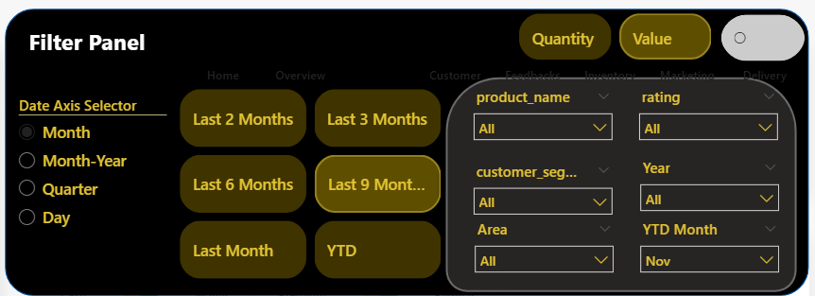

9.1 Quantity vs Value Toggle
At the top of the filter panel, a Quantity–Value toggle is provided to switch the analysis perspective:
- Quantity -> Orders, units sold, volume-based KPIs
- Value -> Revenue, sales value, monetary KPIs
Sales data was prepared using an unpivoted structure, allowing a single slicer to control both views.
Based on the toggle selection:
- All KPIs
- Growth percentages
- Charts and tables
update dynamically across every dashboard page, without changing the layout.

9.2 Date Axis Selector
A Date Axis Selector is included to control how time is displayed in visuals:
- Month
- Month–Year
- Quarter
- Day
This allows users to change the time granularity without modifying visuals manually.

9.3 Time Period Filters
Dedicated quick-selection time buttons are provided to enable fast and flexible time-based analysis:
- Last Month
- Last 2 Months
- Last 3 Months
- Last 6 Months
- Last 9 Months
- Year-to-Date (YTD)
These filters allow users to instantly analyse recent performance and trends without manually selecting dates.
Month-Context Aware Logic
The time period logic is month-context aware, meaning the rolling periods automatically adjust based on the currently selected month.
Example:
- If the selected month is November:
  - Last 3 Months → August, September, October
  - Last 6 Months → May to October
This dynamic approach:
- Avoids hard-coded date filters
- Automatically adapts to different month selections
- Ensures accurate and reliable rolling-period analysis across all dashboard pages

9.4 Business-Level Filters
The filter panel also includes key business slicers to support focused analysis:
- Product Name
- Customer Segment
- Area
- Rating
- Year
- YTD Month
Each slicer affects all visuals on the active page, enabling quick drilldowns.

9.5 Data Scope Toggle (CY / PY vs Full Data)
A data scope toggle button is provided next to the Quantity–Value slicer to control the time range of data displayed in the dashboard.
- Toggle OFF (Default View):
  - All visuals display data for Current Year (CY) and Previous Year (PY) only
  - Used for standard performance comparison and year-over-year analysis
- Toggle ON (Expanded View):
  - All visuals display complete historical data from 2023 to 2025
  - Useful for long-term trend analysis and overall performance review
This toggle dynamically updates:
- All KPIs
- Charts and tables
- Growth and comparison metrics without changing any visuals or filters.

9.6 Hidden Filter Panel (UI & Usability Design)
The entire slicer system is placed inside a slide-in / slide-out filter panel, which can be shown or hidden using a toggle button.
Key benefits of this design:
- Keeps dashboards visually clean and uncluttered
- Allows advanced filtering without occupying screen space
- Provides a professional, app-like user experience
The same filter panel and slicer logic is reused across all dashboard pages, ensuring:
- Consistent filtering behaviour
- No repeated slicer setup
- Faster navigation and analysis

10. Overview Dashboard – Role, Design & Analysis
The Overview Dashboard provides a single-screen summary of Blinkit’s overall performance. It is designed for quick decision-making, helping stakeholders easily understand key trends and navigate to detailed dashboards when deeper analysis is required.

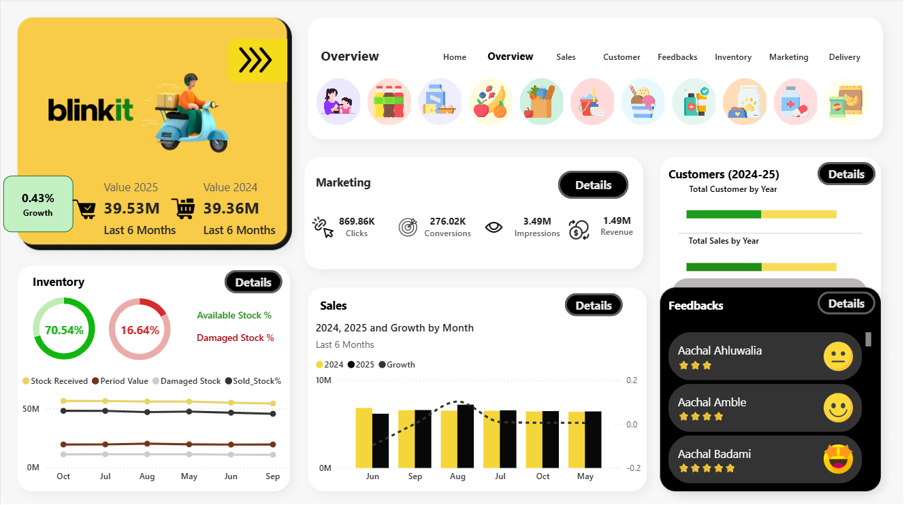
10.1 Purpose of the Overview Dashboard
The main objectives of the Overview page are to:
- Present a high-level summary of all major business functions:
  - Sales
  - Customers
  - Marketing
  - Inventory
  - Feedback
  - Delivery
- Enable quick comparison between years and recent periods
- Allow seamless navigation to detailed dashboards using Details buttons
- Maintain a clean and uncluttered layout by using a hidden slicer panel

10.2 Visuals & Metrics Displayed
10.2.1 KPI Summary Card (Top-Left)
- Displays Sales Value for the selected period (e.g., Last 6 Months)
- Shows Current Year vs Previous Year values
- Includes a growth percentage indicator for quick performance comparison
Insight Use:
Helps quickly identify whether growth is positive or negative and how current performance compares to last year.

10.2.2 Marketing Performance
Metrics shown:
- Impressions
- Clicks
- Conversions
- Revenue
Insight Use:
Provides a snapshot of marketing funnel performance, from visibility to revenue generation.

10.2.3 Customers Snapshot
Metrics shown:
- Total customers by year
- Sales contribution by customer base
Insight Use:
Helps understand customer base growth and its impact on revenue.

10.2.4 Inventory Health Section
Visuals included:
- Available Stock %
- Damaged Stock %
- Trend lines for:
  - Stock received
  - Sold stock
  - Damaged stock
Insight Use:
Identifies inventory health, wastage levels, and stock movement trends.

10.2.5 Sales Trend Chart
Visual elements:
- Monthly sales comparison for 2024 vs 2025
- Growth trend line over time
- Limited to recent months for clarity
Insight Use:
Helps identify seasonal patterns, growth dips, and recent performance trends.
10.2.6 Customer Feedback Panel
Visual elements:
- Recent customer names
- Ratings
- Sentiment icons (angry, disappointed, neutral, happy, very happy)
Insight Use:
Provides a qualitative view of customer experience alongside quantitative metrics.

10.3 Hidden Slicer Panel – How Filtering Works
All visuals on the Overview dashboard are controlled through a hidden filter panel, which can be opened or closed using a toggle button.
Filters Available in the Panel:
- Quantity vs Value toggle
- CY / PY vs Full Data (2023–2025) toggle
- Time filters:
  - Last Month
  - Last 2 / 3 / 6 / 9 Months
  - YTD
- Date axis selector (Month, Month-Year, Quarter, Day)
- Business filters:
  - Product
  - Area
  - Customer Segment
  - Rating
How It Works:
- When a filter is selected, all visuals on the Overview page update instantly
- The same slicer logic is used across all dashboard pages, ensuring consistency
- Filters remain retained when navigating to detailed dashboards using the Details button

10.4 Detail Button Navigation Logic
Each section on the Overview page includes a Details button.
- Clicking the button redirects the user to the corresponding detailed dashboard (Sales, Customers, Marketing, etc.)
- All selected filters from the hidden slicer panel are retained, ensuring continuity in analysis
- This allows users to move smoothly from summary to deep-dive analysis

11. Sales Dashboard – Detailed Analysis
The Sales Dashboard is the first and most important business segment in this project. It provides a comprehensive analysis of revenue performance, order behaviour, product contribution, customer impact, and regional demand trends over time.
All visuals on this dashboard are fully dynamic and controlled through the hidden slicer panel, ensuring consistent and flexible analysis across different time periods, segments, and perspectives.

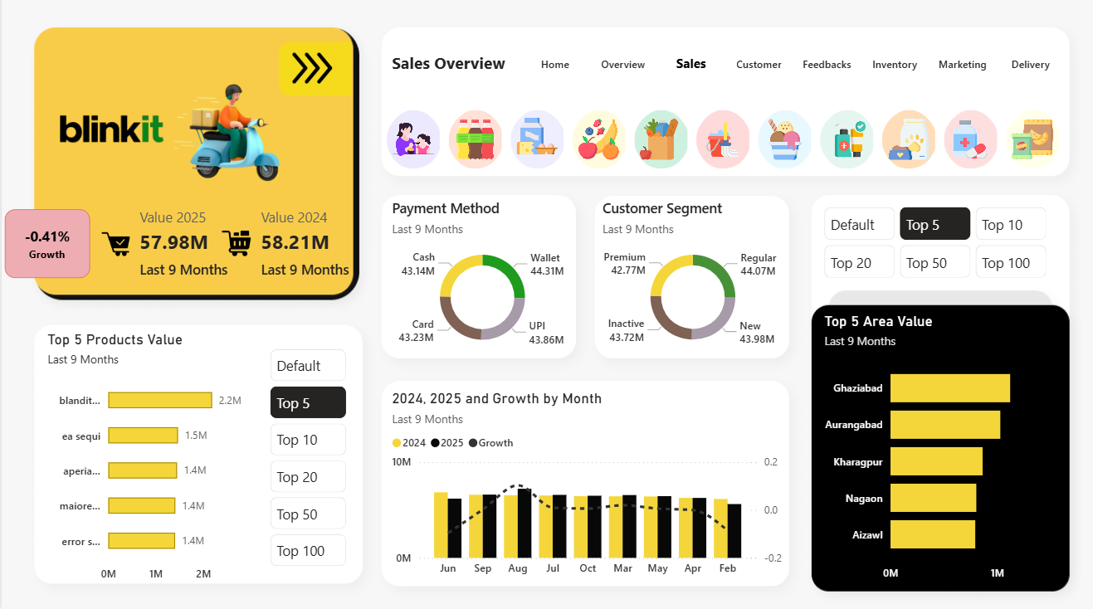

11.1 Purpose of the Sales Dashboard
The primary purpose of the Sales Dashboard is to support both strategic and operational decision-making by answering key business questions, such as:
- How is revenue performing over time?
- Is growth driven by higher sales value or higher order volume?
- Which products and geographic areas contribute the most to sales?
- Which customer segments generate maximum revenue?
- What are the most commonly used payment methods?
- How does performance change across different time periods?
This dashboard acts as a core analytical layer for understanding Blinkit’s sales performance.

11.2 Key KPIs Created (DAX Measures)
To enable detailed and flexible analysis, several DAX measures were created. These KPIs dynamically respond to time filters, Quantity–Value toggle, and Current Year / Previous Year logic.
Core Sales KPIs
- Current Year Sales (CY Sales)
Calculates total sales for the selected period in the current year.
- Previous Year Sales (PY Sales)
Calculates sales for the same period in the previous year.
- CY vs PY Growth %
Measures year-over-year growth or decline in sales.
- Order Count
Displays the total number of orders placed in the selected period.
- Year-to-Date (YTD) Sales
Aggregates sales from the beginning of the year up to the selected month.
- Period-wise Sales
Dynamically calculates sales for custom rolling periods such as Last 3, Last 6, or Last 9 months.
These KPIs form the foundation of all visuals on the Sales Dashboard.

11.3 Visuals Used & Business Explanation

11.3.1 KPI Summary Card
Displays:
- Sales value for the selected period
- Current Year vs Previous Year sales
- Growth percentage
Business Value:
- Instantly shows whether sales are growing or declining
- Enables quick performance assessment without deep analysis

11.3.2 Top N Products by Sales (Column Chart)
Logic Used:
A dynamic Top N slicer with options:
- Default
- Top 5
- Top 10
- Top 20
- Top 50
- Top 100

Business Insight:
- Identifies key revenue-generating products
- Highlights dependency risk on a limited number of products
- Supports:
  - Product prioritization
  - Inventory planning

11.3.3 Top N Areas by Sales (Column Chart)
Logic Used:
Uses the same dynamic Top N selection logic as products.
Business Insight:
- Identifies high-performing regions
- Supports:
  - Regional demand planning
  - Store expansion decisions
  - Local marketing strategies

11.3.4 Payment Method Distribution (Pie Chart)
Payment Modes Analysed:
- UPI
- Card
- Cash
- Wallet
Business Insight:
- Helps understand customer payment preferences
- Evaluates:
  - Digital payment adoption
  - Operational dependency on cash
  - Potential need for payment partnerships

11.4.5 Customer Segment Contribution (Pie Chart)
Segments Included:
- Premium
- Regular
- New
- Inactive
Business Insight:
- Shows revenue dependency on:
  - Loyal and repeat customers
  - Newly acquired customers
- Supports:
  - Retention strategies
  - Customer acquisition planning
11.4.6 2024 vs 2025 Sales Comparison (Column + Line Chart)
Visual Structure:
- Columns represent sales for 2024 and 2025
- Line represents growth percentage
Why This Visual Is Used:
- Combines absolute performance and growth trends in a single view
- Helps identify:
  - Growth acceleration or slowdown
  - Seasonal patterns
  - Performance drops

11.5 Interaction with Hidden Slicer Panel
All visuals on the Sales Dashboard are controlled through a hidden slicer panel, which includes:
- Quantity vs Value toggle
- CY/PY vs Full Data toggle (2023–2025)
- Time filters (Last Month, Last 3/6/9 Months, YTD)
- Product, Area, and Customer Segment filters
How it works:
- Any slicer selection updates all visuals instantly
- Filters remain retained when navigating to other dashboards
- Ensures consistent and reliable analysis across pages

11.6 Key Insights & Results
- A small group of products contributes a significant share of revenue
- Certain regions consistently outperform others
- Revenue growth is not uniform across months
- Loyal and premium customers drive a major portion of sales
- Digital payments dominate over cash transactions
- Growth trends vary significantly across rolling periods

11.7 Key Conclusions
- Sales performance is strongly driven by products and regions
- Both quantity and value perspectives are required for accurate growth analysis
- Rolling-period analysis provides deeper insights than static monthly views
- Customer segmentation plays a critical role in revenue stability

11.8 Future Enhancements & Requirements
If extended further, the Sales Dashboard can be enhanced with:
- Sales forecasting using time-series models
- Discount and promotion impact analysis
- Profitability analysis using cost and margin data
- Store-level performance comparison
12. Customer Dashboard – Detailed Analysis
The Customer Dashboard focuses on analysing customer growth, retention, repeat behaviour, churn, and revenue contribution. It helps understand how customers are acquired, retained, and how their behaviour impacts overall business performance.
All visuals on this dashboard are fully dynamic and controlled through the hidden slicer panel, ensuring consistent analysis across time periods, customer segments, and filters.

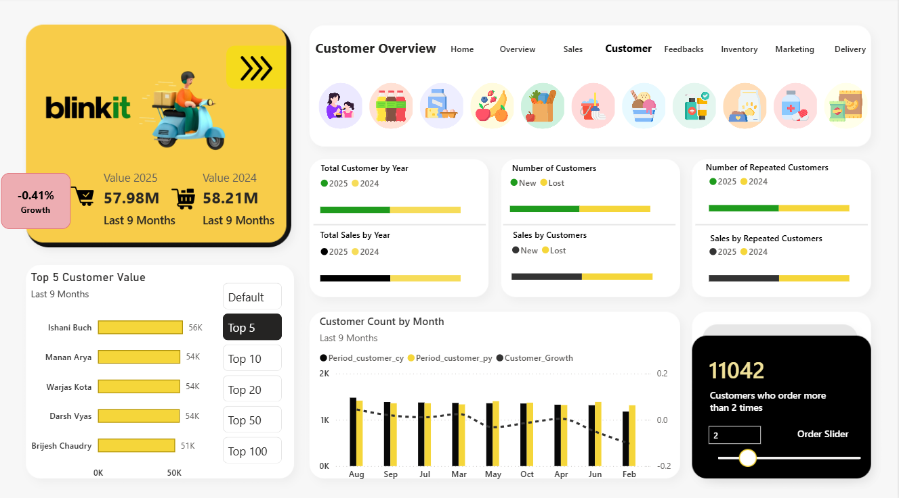

12.1 Purpose of the Customer Dashboard
The Customer Dashboard is designed to answer key customer-centric business questions such as:
- How is the customer base changing over time?
- How many new and lost customers are there?
- What is the repeat customer rate?
- Which customers contribute the highest revenue?
- How does customer behaviour vary across different time periods?
- How many customers place multiple orders?
This dashboard supports customer retention strategy, loyalty planning, and growth analysis.

12.2 Key KPIs Created (DAX Measures)
To support detailed customer analysis, multiple DAX measures were created. These measures respond dynamically to time filters, CY/PY logic, and hidden slicer selections.
Core Customer KPIs
- Customer Revenue (CY)
Calculates the total revenue generated by customers for the selected period in the current year.
- Customer Revenue (PY)
Calculates the total revenue generated by customers for the same period in the previous year.
- Customer Revenue Growth %
Measures the year-over-year growth or decline in revenue generated by customers.
- New Customers
Identifies customers who placed their first order in the selected period.
- Lost Customers
Identifies customers who did not return compared to the previous period.
- Repeated Customers
Calculates customers who placed more than one order.
- Sales by Customers
Measures revenue contribution from customers.
These KPIs form the foundation of all visuals on the Customer Dashboard.

12.3 Visuals Used & Business Explanation
12.3.1 KPI Summary Card
Displays:
- Customer-related sales value
- Current Year vs Previous Year comparison
- Growth percentage
Business Value:
- Quickly shows whether customer-driven revenue is growing or declining.

12.3.2 Total Customers by Year (Bar Visual)
Shows:
- Total customers for 2024 vs 2025
Business Insight:
- Helps track overall customer base growth
- Useful for long-term growth evaluation

12.3.3 New vs Lost Customers (Bar Visual)
Shows:
- Number of new customers
- Number of lost customers
Business Insight:
- Identifies customer acquisition vs churn
- Helps evaluate retention effectiveness
12.3.4 Repeated Customers by Year
Shows:
- Customers who placed multiple orders
- Comparison between 2024 and 2025
Business Insight:
- Measures customer loyalty
- Indicates stability of the customer base

12.3.5 Sales by Customers, New vs Lost, and Repeated Customers
Shows:
- Total sales by customers
  - Comparison of 2024 vs 2025 revenue generated from all customers
- Sales by new vs lost customers
  - Revenue generated by new customers
  - Revenue loss due to customers who did not return
  - (This comparison is based only on sales contribution, not customer count)
- Sales by repeated customers
  - Comparison of 2024 vs 2025 revenue generated by customers who placed multiple orders
Business Insight:
- Clearly separates overall customer-driven revenue from acquisition and churn impact
- Highlights how much revenue is:
  - Generated by new customers
  - Lost due to customer churn
  - Sustained by repeat customers
- Helps evaluate:
  - Effectiveness of customer acquisition strategies
  - Revenue stability driven by loyal customers
  - Need for improved retention and loyalty programs

12.3.6 Customer Count by Month (Column + Growth Line)
Visual Structure:
- Columns -> Customer count (CY vs PY)
- Line -> Customer growth trend
Business Insight:
- Shows monthly customer acquisition trends
- Identifies periods of growth or decline

12.3.7 Top N Customers by Sales Value (Bar Chart)
Logic Used:
Dynamic Top N slicer with options:
- Default
- Top 5
- Top 10
- Top 20
- Top 50
- Top 100
Business Insight:
- Identifies high-value customers
- Useful for premium customer targeting

12.3.8 Repeat Order Threshold Slider
Feature:
- Slider to define customers ordering more than N times
- Example: Customers who ordered more than 2 times
Business Insight:
- Allows flexible analysis of repeat behaviour
- Helps identify truly loyal customers

12.4 Key Insights & Results from Customer Dashboard
- Customer growth is not uniform across months
- A smaller group of customers contributes a large share of revenue
- Repeat customers play a major role in sales stability
- Customer churn exists alongside acquisition
- Revenue dependency on loyal customers is high

12.5 Key Conclusions
- Customer retention is as important as acquisition
- Repeat customers are critical for revenue stability
- Growth analysis must consider new vs lost customers
- Monthly and rolling-period analysis gives deeper insights than static views

12.6 Future Enhancements & Requirements
The Customer Dashboard can be enhanced further by adding:
- Customer lifetime value (CLV) analysis
- Cohort-based retention analysis
- Customer churn prediction models
- Personalized offer and recommendation insights
- Customer behaviour segmentation using clustering

13. Feedback Dashboard – Detailed Analysis
The Feedback Dashboard focuses on analysing customer satisfaction, service quality, sentiment trends, and feedback patterns. It converts raw feedback data into actionable insights by combining ratings, sentiment classification, feedback categories, and customer details.
This dashboard helps understand what customers feel, why they feel that way, and which areas of the business require improvement.

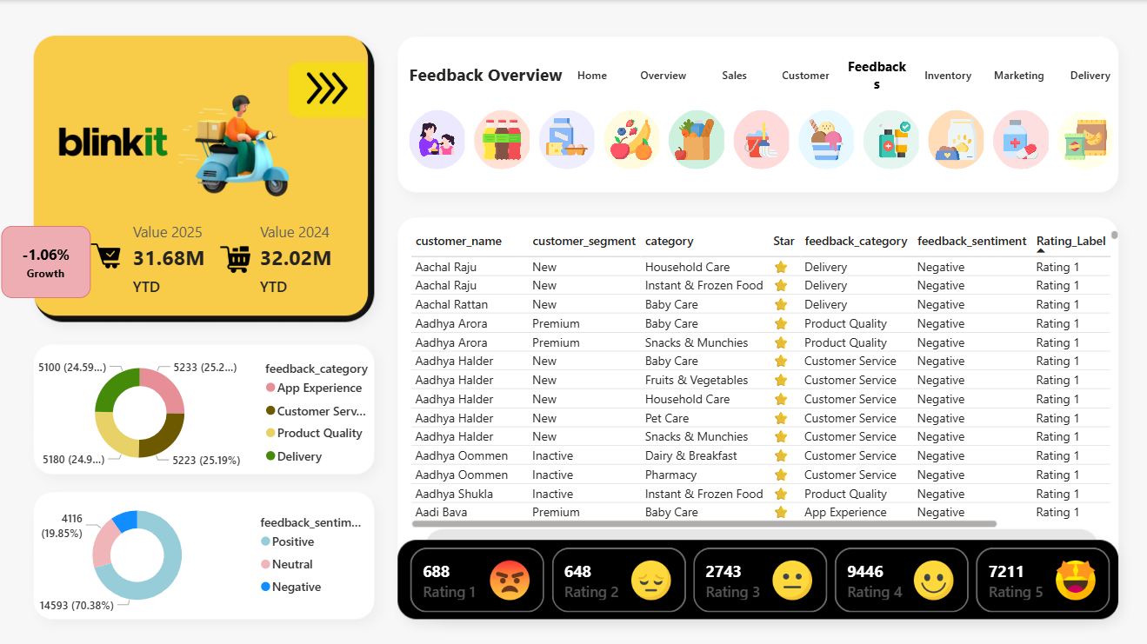

13.1 Purpose of the Feedback Dashboard
The Feedback Dashboard is designed to answer key customer-experience questions such as:
- What is the overall customer satisfaction level?
- How are ratings distributed across 1 to 5 stars?
- What is the split between positive, neutral, and negative feedback?
- Which feedback categories receive the most complaints?
- Which customer segments and product categories generate negative feedback?
- How does feedback impact overall business perception?
This dashboard supports service improvement, quality control, and customer experience strategy.

13.2 Visuals Used & Business Explanation

13.2.1 Feedback Category Distribution (Donut Chart)
Categories Analysed:
- Delivery
- Product Quality
- Customer Service
- App Experience
Business Insight:
- Identifies major sources of customer complaints
- Helps prioritize operational improvements
- Supports targeted corrective actions by category

13.2.2 Feedback Sentiment Distribution (Donut Chart)
Sentiments Shown:
- Positive
- Neutral
- Negative
Business Insight:
- Provides a quick overview of overall customer mood
- Helps track sentiment shifts over time
- Useful for monitoring service quality impact

13.2.3 Detailed Feedback Table
Columns Displayed:
- Customer Name
- Customer Segment
- Product Category
- Rating (Star-based)
- Feedback Category
- Feedback Sentiment
- Rating Label
Business Insight:
- Enables row-level analysis of individual feedback
- Helps identify patterns across:
  - Customer segments
  - Product categories
  - Feedback types
- Useful for root-cause analysis

13.2.4 Rating Distribution Cards (1–5 Star)
Displays:
- Total count of feedback for each rating level
- Emoji-based visual indicators for easy interpretation
Business Insight:
- Highlights distribution of poor, average, and excellent experiences
- Helps track improvement or decline in customer satisfaction
- Useful for setting service quality benchmarks

13.3 Key Insights & Results from Feedback Dashboard
- A large portion of feedback falls under Delivery and Customer Service
- Negative feedback is concentrated around lower ratings (1–2 stars)
- Premium customers tend to give more detailed feedback
- Certain product categories receive repeated complaints
- Sentiment trends vary across time periods

13.4 Key Conclusions
- Customer experience issues are category-specific
- Delivery and service quality play a major role in negative feedback
- Rating and sentiment analysis together provide deeper insight than ratings alone
- Feedback data is essential for continuous service improvement

13.5 Future Enhancements & Requirements
The Feedback Dashboard can be enhanced further by adding:
- Text-based sentiment analysis using NLP
- Keyword extraction from feedback comments
- Feedback trend alerts for sudden spikes in negative sentiment
- Linking feedback with delivery delays and refunds
- Predictive customer satisfaction scoring

14. Inventory Dashboard – Detailed Analysis
The Inventory Dashboard focuses on monitoring stock availability, stock movement, sales consumption, and inventory losses. It helps evaluate how efficiently inventory is managed and whether stock levels are aligned with sales demand.
This dashboard converts raw inventory data into clear, actionable insights that support inventory planning, wastage reduction, and operational efficiency.

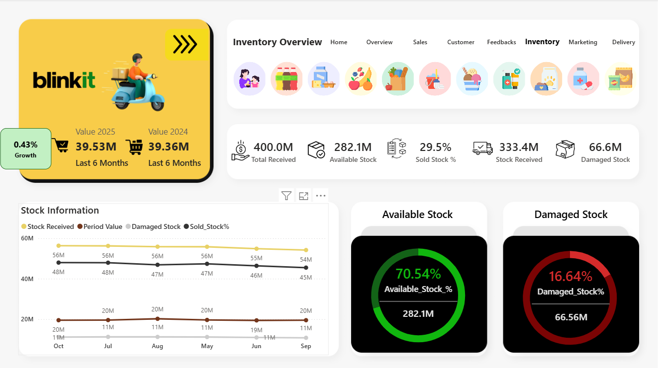

14.1 Purpose of the Inventory Dashboard
The Inventory Dashboard is designed to answer key operational questions such as:
- How much stock is received, available, sold, and damaged?
- What percentage of inventory is available vs damaged?
- How does inventory movement change over time?
- Is stock consumption aligned with sales demand?
- Where are potential inventory inefficiencies or losses?
This dashboard supports supply chain management, warehouse planning, and cost control.

14.2 Key KPIs Created (DAX Measures)
To support inventory analysis, multiple DAX measures were created
Core Inventory KPIs
- Total Stock Received
Calculates the total quantity of stock received during the selected period.
- Available Stock
Measures the current usable stock available for sale.
- Sold Stock %
Calculates the percentage of stock sold relative to total stock received.
- Damaged Stock
Measures the total quantity of damaged or unusable stock.
- Available Stock %
Calculates the proportion of available stock out of total stock received.
- Damaged Stock %
Calculates the percentage of stock lost due to damage.
These KPIs form the foundation of all visuals on the Inventory Dashboard.

14.3 Visuals Used & Business Explanation
14.3.1 KPI Summary Card
Displays:
- Total stock received
- Available stock
- Sold stock percentage
- Damaged stock
Business Value:
- Provides a quick overview of inventory health
- Helps identify stock sufficiency and loss levels

14.3.2 Stock Information Trend Chart
Metrics Tracked Over Time:
- Stock received
- Period value
- Sold stock percentage
- Damaged stock
Business Insight:
- Shows inventory movement trends
- Helps detect mismatches between stock inflow and consumption
- Useful for identifying overstocking or understocking patterns

14.3.3 Available Stock Indicator (Donut Chart)
Displays:
- Available stock percentage
- Total available stock quantity
Business Insight:
- Shows how much inventory is currently usable
- Helps assess inventory readiness to meet demand

14.3.4 Damaged Stock Indicator (Donut Chart)
Displays:
- Damaged stock percentage
- Total damaged stock quantity
Business Insight:
- Highlights inventory loss
- Supports initiatives to reduce wastage and handling issues

14.4 Key Insights & Results from Inventory Dashboard
- A large portion of stock remains available and usable
- Damaged stock forms a significant but manageable percentage
- Stock received and sold follow consistent trends
- Inventory losses can be monitored and controlled over time
- Rolling-period analysis reveals gradual changes in stock health

14.5 Key Conclusions
- Inventory management is generally efficient but requires continuous monitoring
- Reducing damaged stock can significantly improve operational efficiency
- Aligning stock levels with sales demand is critical
- Rolling inventory trends provide better insight than static views

14.6 Future Enhancements & Requirements
The Inventory Dashboard can be enhanced further by adding:
- Product-level stock aging analysis
- Reorder level alerts
- Inventory turnover ratio
- Supplier performance tracking
- Integration with demand forecasting models

15. Marketing Dashboard – Detailed Analysis
The Marketing Dashboard focuses on analysing marketing performance, campaign effectiveness, customer engagement, and return on marketing spend. It helps evaluate how efficiently marketing efforts are converted into revenue and whether spending is generating the expected business outcomes.
This dashboard transforms raw marketing data into clear performance indicators that support budget planning, campaign optimization, and ROI-driven decision-making.

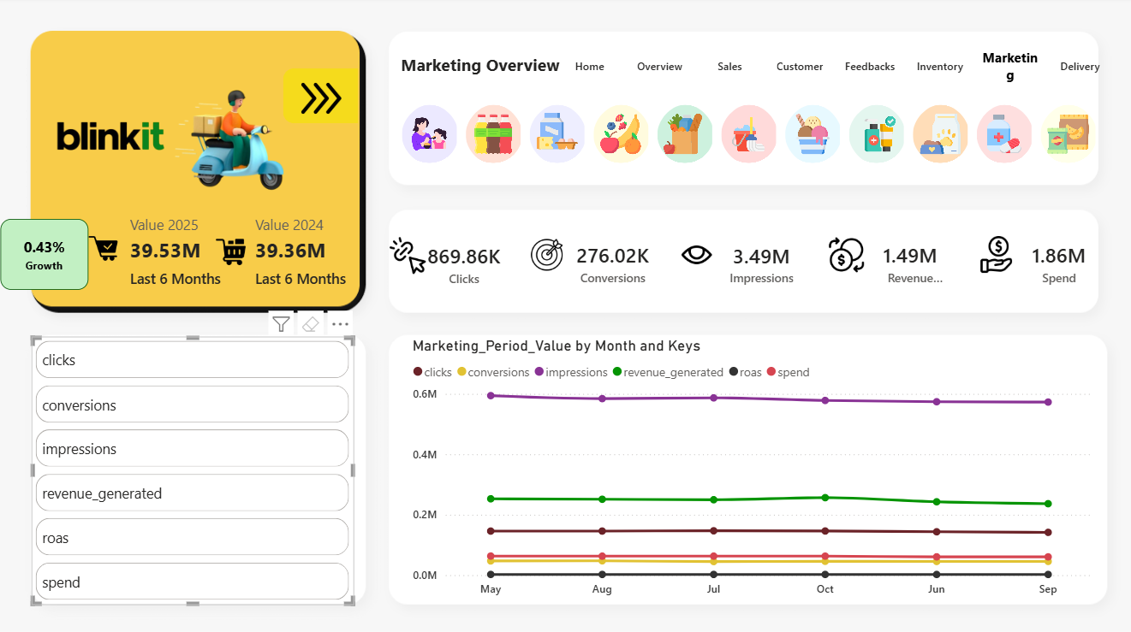

15.1 Purpose of the Marketing Dashboard
The Marketing Dashboard is designed to answer key business questions such as:
• How effective are marketing campaigns in generating clicks, conversions, and revenue?
• How much spend is required to generate returns?
• How does marketing performance change over time?
• Is marketing spend aligned with revenue generation?
• Which marketing metrics show improvement or decline across periods?
This dashboard supports marketing strategy evaluation, budget optimization, and performance tracking.

15.2 Key KPIs Created (DAX Measures)
To support marketing analysis, multiple DAX measures were created.
Core Marketing KPIs
• Total Impressions
Calculates the total number of times marketing content was viewed.
• Total Clicks
Measures the number of user interactions with marketing campaigns.
• Total Conversions
Calculates the number of successful actions completed after clicks.
• Revenue Generated
Measures the total revenue generated through marketing campaigns.
• Marketing Spend
Calculates the total amount spent on marketing activities.
• ROAS (Return on Ad Spend)
Measures the efficiency of marketing spend by comparing revenue generated against spend.
These KPIs form the foundation of all visuals on the Marketing Dashboard.

15.3 Visuals Used & Business Explanation
15.3.1 KPI Summary Card
Displays:
• Clicks
• Conversions
• Impressions
• Revenue generated
• Marketing spend
Business Value:
• Provides a quick overview of overall marketing performance
• Helps assess whether marketing efforts are driving engagement and revenue

15.3.2 Marketing Metric Selector (Key-Based Analysis)
Metrics Available:
• Clicks
• Conversions
• Impressions
• Revenue generated
• ROAS
• Spend
Business Insight:
• Allows users to analyse one marketing metric at a time
• Enables focused analysis without overcrowding the visual
• Improves clarity when comparing trends across months

15.3.3 Marketing Performance Trend Chart (Line Chart)
Metrics Tracked Over Time:
• Clicks
• Conversions
• Impressions
• Revenue generated
• Spend
• ROAS
Business Insight:
• Shows how different marketing metrics move over time
• Helps identify:
- High-spend but low-return periods
- Consistent revenue-generating campaigns
- Gaps between engagement and conversions
- Supports optimization of marketing strategies

15.4 Key Insights & Results from Marketing Dashboard
• Impressions and clicks follow consistent trends over time
• Conversion levels indicate how effectively engagement turns into sales
• Revenue does not always increase proportionally with spend
• ROAS helps identify efficient vs inefficient marketing periods
• Trend analysis highlights opportunities to optimize campaign timing and budget allocation

15.5 Key Conclusions
• Marketing performance must be evaluated beyond clicks and impressions
• Revenue and ROAS are critical for understanding true campaign success
• Controlled spending with steady conversions improves overall efficiency
• Time-based trend analysis provides better insights than single-period views

15.6 Future Enhancements & Requirements
The Marketing Dashboard can be enhanced further by adding:
• Campaign-level and channel-level performance analysis
• Cost-per-click (CPC) and cost-per-conversion metrics
• Attribution analysis across customer journeys
• A/B testing insights for campaign creatives
• Predictive models for marketing ROI optimization

16. Delivery Dashboard – Detailed Analysis
The Delivery Dashboard focuses on analysing delivery performance, timeliness, delays, and operational efficiency. It helps understand how well orders are delivered within promised timelines and identifies areas causing delivery delays.
This dashboard converts delivery-related data into clear operational insights that support logistics optimization, customer satisfaction improvement, and delivery performance monitoring.

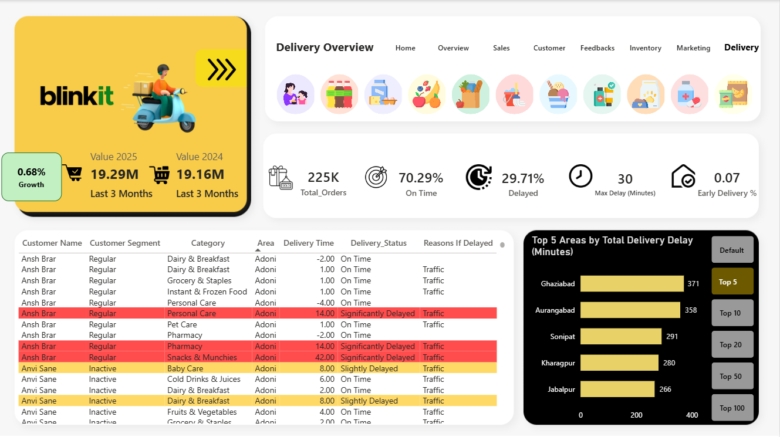

16.1 Purpose of the Delivery Dashboard
The Delivery Dashboard is designed to answer key operational questions such as:
• How many orders are delivered in the selected period?
• What percentage of orders are delivered on time vs delayed?
• How severe are delivery delays?
• Which areas experience the highest delivery delays?
• What are the main reasons for delivery delays?
• How does delivery performance impact customer experience?
This dashboard supports logistics planning, delivery partner management, and service quality improvement.

16.2 Key KPIs Created (DAX Measures)
To support delivery analysis, multiple DAX measures were created.
Core Delivery KPIs
• Total Orders
Calculates the total number of orders delivered during the selected period.
• On-Time Delivery %
Measures the percentage of orders delivered within the promised delivery time.
• Delayed Delivery %
Calculates the percentage of orders delivered after the promised time.
• Maximum Delay (Minutes)
Identifies the longest delivery delay observed in the selected period.
• Early Delivery %
Measures the percentage of orders delivered earlier than the promised time.
These KPIs form the foundation of all visuals on the Delivery Dashboard.

16.3 Visuals Used & Business Explanation
16.3.1 KPI Summary Card
Displays:
• Total orders
• On-time delivery percentage
• Delayed delivery percentage
• Maximum delay in minutes
• Early delivery percentage
Business Value:
• Provides a quick overview of delivery performance quality
• Helps assess reliability and speed of the delivery system

16.3.2 Detailed Delivery Table
Columns Displayed:
• Customer name
• Customer segment
• Product category
• Area
• Delivery time (minutes)
• Delivery status (On Time / Slightly Delayed / Significantly Delayed)
• Reason for delay
Business Insight:
• Enables row-level analysis of delivery performance
• Helps identify:
- Frequently delayed customers
- Delay-prone product categories
- Common delay reasons (e.g., traffic)
- Useful for root-cause analysis and corrective action planning

16.3.3 Top N Areas by Total Delivery Delay (Bar Chart)
Logic Used:
Dynamic Top N selection with options:
• Default
• Top 5
• Top 10
• Top 20
• Top 50
• Top 100
Business Insight:
• Identifies areas with highest cumulative delivery delays
• Helps prioritize:
- Route optimization
- Delivery partner allocation
- Area-specific operational improvements

16.4 Key Insights & Results from Delivery Dashboard
• Most orders are delivered on time, indicating good operational efficiency
• Delivery delays are concentrated in specific areas
• Traffic is a major contributor to delivery delays
• Some product categories experience higher delay frequency
• Extreme delays are rare but have a strong impact on customer experience

16.5 Key Conclusions
• On-time delivery performance is generally strong but uneven across locations
• Area-level analysis is critical for reducing overall delivery delays
• Monitoring maximum delay helps identify operational bottlenecks
• Improving delivery speed can significantly enhance customer satisfaction

16.6 Future Enhancements & Requirements
The Delivery Dashboard can be enhanced further by adding:
• Delivery partner performance analysis
• Route-level delay analysis
• Predictive delay risk scoring
• Weather and traffic data integration
• SLA compliance tracking

17. Final Project Conclusion & Business Recommendations
17.1 Project Conclusion
This project successfully delivers an end-to-end Business Intelligence and Data Analytics solution for Blinkit, covering the period 2023–2025. Using SQL for data integration and Power BI for modelling, DAX calculations, and visualization, raw operational data was transformed into interactive, decision-ready dashboards.
The project analysed Blinkit’s performance across six core business functions:
- Sales
- Customers
- Feedback
- Inventory
- Marketing
- Delivery
A centralized and consistent analytics framework was implemented, where all dashboards respond dynamically to common time logic, filters, and comparison views (CY/PY and full historical data). The use of advanced DAX-based time intelligence, rolling-period analysis, and standardized KPIs ensures accuracy, flexibility, and scalability.
Overall, the dashboards enable stakeholders to:
- Monitor performance at a high level
- Drill down into specific problem areas
- Make faster, data-driven decisions
This project demonstrates practical skills in data modelling, business analytics, KPI design, and dashboard storytelling, making it suitable for real-world BI and Data Analyst roles.

17.2 Key Business Insights (Overall)
From the combined analysis of all dashboards, the following high-level insights emerged:
- Revenue growth is not uniform and depends heavily on products, regions, and customer segments
- A small group of top products and loyal customers contributes a large share of revenue
- Delivery performance and customer service have a strong impact on customer feedback and satisfaction
- Inventory losses (damaged stock) directly affect operational efficiency and costs
- Marketing spend does not always translate proportionally into revenue, highlighting the importance of ROAS-based evaluation
- Rolling-period analysis provides more reliable insights than static monthly comparisons

17.3 Business Recommendations
Based on the insights generated from the dashboards, the following actionable business recommendations are proposed:
1. Sales & Revenue Optimization
- Reduce dependency on a small set of products by diversifying the product mix
- Focus promotional strategies on high-performing regions
- Use rolling-period trends to identify early signs of sales slowdown
2. Customer Retention & Growth
- Strengthen loyalty programs for repeat and premium customers
- Monitor new vs lost customer revenue to reduce churn
- Target high-value customers with personalized offers
3. Feedback & Customer Experience
- Prioritize improvement in delivery and customer service, as they generate the highest negative feedback
- Use feedback trends to implement preventive service improvements
- Track rating and sentiment changes after operational changes
4. Inventory Management
- Reduce damaged stock through better handling, storage, and supplier monitoring
- Align stock replenishment more closely with sales demand trends
- Introduce inventory aging and reorder alerts to prevent losses
5. Marketing Effectiveness
- Shift focus from vanity metrics (impressions, clicks) to ROAS and conversions
- Optimize spend by reducing investment in low-return periods or campaigns
- Test and refine campaigns using time-based performance trends
6. Delivery & Operations
- Improve delivery performance in delay-prone areas
- Use delay reasons (e.g., traffic) to optimize routes and schedules
- Track extreme delays closely to prevent negative customer impact

17.4 Scope for Future Enhancement
This analytics system can be further enhanced by:
- Sales and demand forecasting using time-series models
- Customer lifetime value (CLV) and churn prediction models
- Text-based sentiment analysis using NLP on feedback comments
- Real-time dashboard refresh with live data pipelines
- Integration of external data (weather, traffic, promotions)

17.5 Final Note
This project demonstrates how data analytics and BI tools can convert complex operational data into meaningful insights. The structured approach, standardized KPIs, and interactive dashboards provide a strong foundation for scalable analytics in a fast-growing business like Blinkit.
In conclusion, the project highlights the power of data-driven decision-making and showcases practical, job-ready skills in SQL, Power BI, and business analytics.

Blinkit Dashboard – DAX Measure Documentation

1.Auto_Date
Object Type - Calculated Table
Name: Auto_Date
Column: Options (Text)
Purpose:
Provides a disconnected slicer that allows users to switch between system-driven date logic and manually selected calendar logic.
Structure:
One text column (Options) containing a single blank value.
Logic Usage:
Used with ISFILTERED() in time intelligence measures to determine whether to use the current system date or user-selected calendar filters.
Business Impact:
Enables dashboards to toggle between real-time reporting and historical analysis.

2. CONFIGURATION TABLE
2.1 Current_Year
Table: Configuration

Formula
Current_year =
var yr = 2025
var Sys_Year = YEAR([System_Date])
RETURN IF(ISFILTERED(Auto_Date[Options]), Sys_Year, yr)

Explanation
Explanation
- yr = 2025 → default year.
- Sys_Year → current calendar year from system clock.
- ISFILTERED(Auto_Date[Options]) checks if user selected automatic mode.
- If yes → use system year.
- Else → fallback to 2025.

Business Use
Controls which year is treated as “current” for all YoY KPIs.

2.2 previous_year
Table: Configuration
Formula
Previous_year = [Current_Year]-1

Explanation
Simply subtracts 1 from Current_Year.
Use
Previous-year comparison.

2.3 year_before_previous
Table: Configuration
Formula
Year_before_previous = [Current_Year] -2

Use
Two-year historical comparison.

2.4 System_Date
Table: Configuration
formula
system_date = NOW()

Explanation
Returns current system timestamp.
Use
Dynamic dashboards that auto-update.

2.5 YTD_Month
Table: Configuration
Formula
Ytd_month =
var Sys_Month = MONTH([System_Date])
var Selected_YTD_Month = SELECTEDVALUE(Manual_Calendar[MonthIndex])
RETURN IF(ISFILTERED(Auto_Date[Options]),Sys_Month,Selected_YTD_Month)
Explanation
- Sys_Month → current month number derived from the system date.
- Selected_YTD_Month → month selected by the user from the Manual Calendar slicer.
- ISFILTERED(Auto_Date[Options]) → checks whether the Auto Date toggle is active.
- If yes → use system month.
- Else → fallback to manually selected month.

Business Purpose
Controls which month is used for YTD and rolling-period calculations, allowing the dashboard to switch between real-time and user-driven historical analysis.

3. Sales Measures
Purpose:
Sales measures form the core analytical layer of the dashboard. They calculate revenue, time-based trends, year-over-year comparisons, rolling-period metrics, order volumes, Top N rankings, and conditional formatting signals.
Why They Were Created:
• To support YTD and rolling-period analysis.
• To enable Current vs Previous year comparisons.
• To calculate growth percentages.
• To power Top N product and area rankings.
• To track order volumes and sales momentum.
• To visually highlight performance using conditional formatting.
Business Impact:
These measures allow Blinkit stakeholders to monitor revenue performance, identify growth or decline, compare periods, and quickly spot top-performing or underperforming regions and products.

3.1 Value
Formula
SUM(MasterTable[Value])

Explanation
- SUM(MasterTable[Value]) → adds up the sales value from all rows in the MasterTable.
Business Purpose
- Acts as the base revenue measure used across all sales KPIs, trends, rankings, and growth calculations.

3.2 Sales YTD
Formula
Ytd = var YTD_SYS_Month = [YTD_Month]
RETURN
CALCULATE([Value],'Calendar'[MonthIndex]<=YTD_SYS_Month)

Explanation
- YTD_SYS_Month → retrieves the month number selected for YTD logic.
- CALCULATE(...) → recalculates Value under a modified filter context.
- 'Calendar'[MonthIndex] <= YTD_SYS_Month → restricts data to months up to the selected YTD month.
Business Purpose
- Calculates year-to-date sales for the selected year, supporting cumulative trend analysis and executive KPIs.
3.3 Period Wise Sales:
Formula
Period_Value = var selected_period = [Selected_Period]
var selected_month = [YTD_Month]
var Start_Index = selected_month - selected_period

var Period_Value =
CALCULATE(
[Value],
'Calendar'[MonthIndex] >= Start_Index,
'Calendar'[MonthIndex] < selected_month
)

RETURN IF([Selected_Period] = 0, [YTD], Period_Value)

Explanation
- selected_period → number of months chosen in the period slicer.
- selected_month → month index used as the end point.
- Start_Index → calculates the first month of the rolling window.
- CALCULATE(...) → recalculates Value for only the selected range of months.
- IF([Selected_Period] = 0, [YTD], Period_Value) → if no period is selected, fallback to YTD calculation.
Business Purpose
- Computes rolling-period sales (for example last 3 or 6 months), enabling short-term performance monitoring alongside YTD views.

3.4 Current_year_Sales
Formula
Current_year_value = var Curryear = [Current_Year]
RETURN
CALCULATE([Period_Value],'Calendar'[Year] = Curryear)

Explanation
- Curryear → retrieves the dynamically selected current year.
- CALCULATE(...) → re-evaluates Period_Value under a new filter context.
- 'Calendar'[Year] = Curryear → restricts calculations to the current year.

Business Purpose
- Returns rolling-period or YTD sales specifically for the current year to support YoY comparison visuals.

3.5 Previous_year_value
Formula
previous_year_value =
var prev_year = [previous_year]
RETURN
CALCULATE([Period_Value],'Calendar'[Year] = prev_year)

Explanation
- prev_year → fetches the year before the current year.
- CALCULATE(...) → recalculates Period_Value for that year only.
Business Purpose
- Provides previous-year sales for YoY growth analysis.

3.6 CY_PY_Growth%
Formula
Cy_py_growth% = var val =
DIVIDE(
[Current_year_value] - [Previous_year_value],
[Previous_year_value]
)

return IF(ISBLANK(val),0,val)

Explanation
- [Current_year_value] − [Previous_year_value] → calculates sales difference.
- DIVIDE(...) → safely divides to avoid divide-by-zero errors.
- ISBLANK(val) → checks for missing results.
- If blank → return 0.
Business Purpose
- Calculates year-over-year sales growth percentage.

3.7 Measure: Positive_&_Negative_Growth_BG_Colour
Formula
IF([CY_PY_Growth%]>=0,"#C2f0c3","#EDADB2")

Explanation
- [CY_PY_Growth%] >= 0 → checks if growth is positive.
- If TRUE → return green color code.
- Else → return red color code.
Business Purpose
- Used for conditional formatting to visually highlight positive vs negative performance.

3.7 Measure: Positive_&_Negative_Growth_Txt_Colour
Formula
IF([CY_PY_Growth%]>=0,"#035505","#de6a73")

Explanation
- Checks growth sign.
- Returns dark green for positive values.
- Returns red shade for negative values.

Business Purpose
- Controls font colour in KPI cards or tables.

3.8 Measure: TopN_Area_by_Value
Formula
var rank_value =
RANKX(
ALL(MasterTable[area]),
[Period_Value],
,
DESC
)

var _rank = SELECTEDVALUE(Rank_Table[Value])

var Rank_Top_N_Value =
IF(rank_value<= _rank, [Period_Value], BLANK())

RETURN IF(_rank = 0, [Period_Value],Rank_Top_N_Value)

Explanation
- RANKX(...) → ranks areas by Period_Value.
- ALL(...) → removes existing area filters.
- _rank → Top-N value chosen by user.
- rank_value <= _rank → keeps only Top-N areas.
- If _rank = 0 → show all areas.
Business Purpose
- Drives dynamic Top-N sales analysis by area.

3.9 Measure: TopN_Product_by_Value
Formula
var rank_value =
RANKX(
ALL(MasterTable[product_name]),
[Period_Value],
,
DESC
)

var _rank = SELECTEDVALUE(Rank_Table[Value])

var Rank_Top_N_Value =
IF(rank_value<= _rank, [Period_Value], BLANK())

RETURN IF(_rank = 0, [Period_Value],Rank_Top_N_Value)
Explanation
- Ranks products by sales.
- Uses slicer-selected Top-N value.
- Shows only top performers.
Business Purpose
- Supports Top-N product performance visuals.

3.10 Measure: Growth_line
Formula
DIVIDE(
[Current_year_value]-[Previous_year_value],
[Previous_year_value]
)

Explanation
- Calculates YoY sales difference ratio.
- Uses safe division.

Business Purpose
- Used in trend lines to visualize growth movement.

3.11 Measure: Order_ID_Count

Formula
DISTINCTCOUNT(MasterTable[order_id])

Explanation
- Counts unique order IDs.

Business Purpose
- Tracks order volume across periods.

3.12 Measure: Period_Orders
Formula
var selected_period = [Selected_Period]
var selected_month = [YTD_Month]
var Start_Index = selected_month - selected_period

var Period_Value =
CALCULATE(
[Order_ID_Count],
'Calendar'[MonthIndex]>= Start_Index,
'Calendar'[MonthIndex]< selected_month
)

RETURN IF([Selected_Period] = 0, [YTD], Period_Value)

Explanation
- selected_period → rolling window length.
- selected_month → ending month.
- Start_Index → beginning month.
- CALCULATE(...) → counts orders only in that window.
- If no period → fallback to YTD.
Business Purpose
- Calculates rolling-period order volume.

3.13 Measure: YTD_orders

Formula
var YTD_SYS_Month = [YTD_Month]
RETURN
CALCULATE([Order_ID_Count],'Calendar'[MonthIndex]<=YTD_SYS_Month)
Explanation
- YTD_SYS_Month → selected YTD cutoff month.
- CALCULATE(...) → counts orders only up to that month.
Business Purpose
- Returns year-to-date order totals.

4. Dynamic Title Measures -
Purpose:
Dynamic Title measures were created to make dashboard visuals automatically update their headings based on user selections such as time period, metric type (Value vs Quantity), year (Current vs Previous), ranking level, and customer thresholds.
Why They Were Created:
• To avoid hard-coded visual titles.
• To clearly communicate the current filter context to business users.
• To improve executive readability and storytelling.
• To ensure users always understand what the KPI represents.
• To support slicer-driven analysis without confusion.
Business Impact:
Dynamic titles reduce misinterpretation of charts and allow the same visual to adapt across multiple scenarios, improving usability for decision-makers.

4.1 Measure: Sale_and_Current_Year_Title
Formula
[Select_Timeperiod_Label] & " "
& [selected_sale_or_qty] & " "
& [Current_Year]

Explanation
- Select_Timeperiod_Label → returns the selected time period label from slicer (for example: YTD, Last 3 Months).
- selected_sale_or_qty → returns whether user selected Value or Quantity.
- Current_Year → appends the current year number.
- "&" → concatenates all text parts into a single dynamic title.
Business Purpose
- Generates a dynamic visual title for current-year sales or quantity cards and charts.

4.2 Measure: selected_sale_or_qty
Formula
SELECTEDVALUE(Value_Options[Value_Type])

Explanation
- SELECTEDVALUE(...) → returns the single value chosen in the Value_Options slicer.
- Value_Type → column containing metric types such as Value or Quantity.
Business Purpose
- Controls whether visuals and titles reflect revenue or volume analysis.

4.3 Measure: Select_Timeperiod_Label
Formula
SELECTEDVALUE(Time_Period[Options])

Explanation
- Returns the time-period label selected by the user (for example: YTD, Last 6 Months).
Business Purpose
- Drives dynamic headings and context text for period-based visuals.

4.4 Measure: Sale_and_Previous_Year_Title
Formula
[Select_Timeperiod_Label] & " "
& [selected_sale_or_qty] & " "
& [previous_year]

Explanation
- Uses the selected time period label.
- Uses the selected metric type.
- Appends previous year instead of current year.
Business Purpose
- Creates a dynamic title for previous-year comparison visuals.

-

